<https://itella.ee/kuidas-pakki-tagastada/>

<https://my.smartpost.ee/return_parcel>

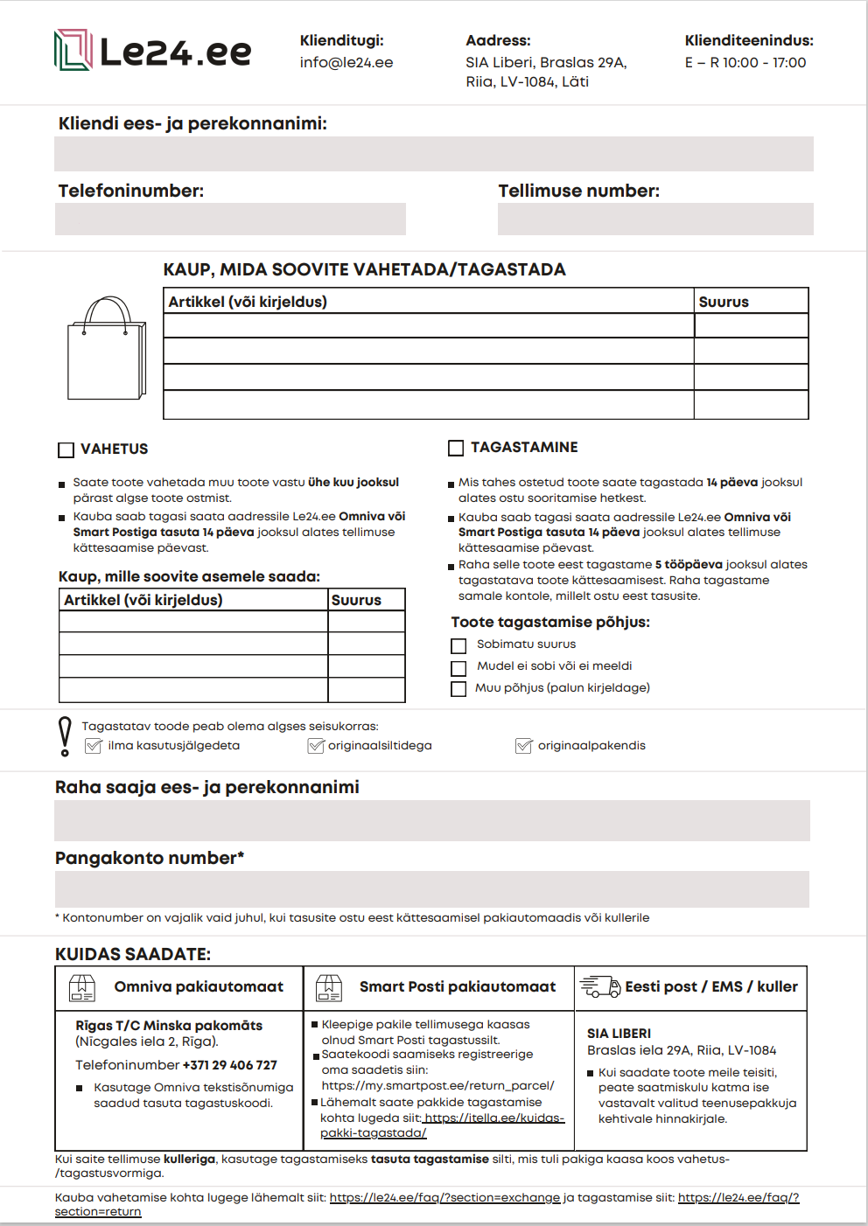

<https://le24.ee/faq/?section=exchange>

<https://le24.ee/faq/?section=return>